
Company
Logotype

Cone Beam Computed Tomography- Report



Porur Dental X-rays & CBCT

Patient Name : Mr. Santhosh | Date of Report : 19.08.2024
Age/ Gender : 15 years/ Male | Region of Interest : CBCT Sectional Maxilla
Referring doctor: Dr. Subramoniam | Indication : Impacted tooth- 23
Clinical Notes: Nil
PATIENT INFORMATION

CBCT Sectional Maxilla provided
CBCT – IMAGE DETAILS

RADIOGRAPHIC INTERPRETATION

- Deciduous tooth present in the anterior maxillary region: 63.
- The tooth 23 appears to be within the alveolar bone, distally tipped with its crown near the radicular portion of 22, 63, 24 and root of 23 in contact with the medial wall of left maxillary sinus and in proximity to the floor of nasal cavity.
- The tooth 23 is positioned such that it involves the labial cortical bone and also causes extreme thinning of it.
- Fractured crown: 22
- Dilacerated palatal root tip: 24.

RADIOGRAPHIC IMPRESSION


- Impacted tooth: 23.
- Retained deciduous teeth: 63.
- Fractured crown: 22
- Dilacerated palatal root tip: 24.

IMAGES FOR REFERENCE

RECONSTRUCTED PANORAMIC VIEW
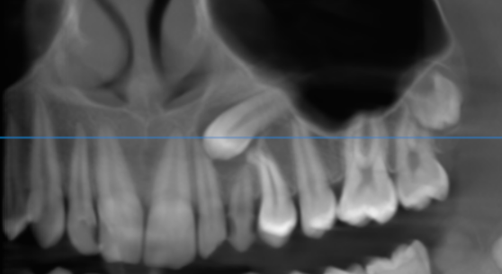

3-DIMENSIONAL VIEW
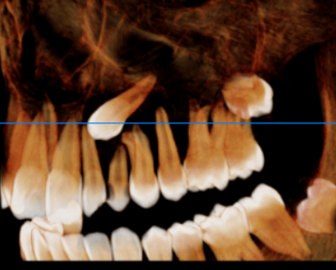

23 REGION | 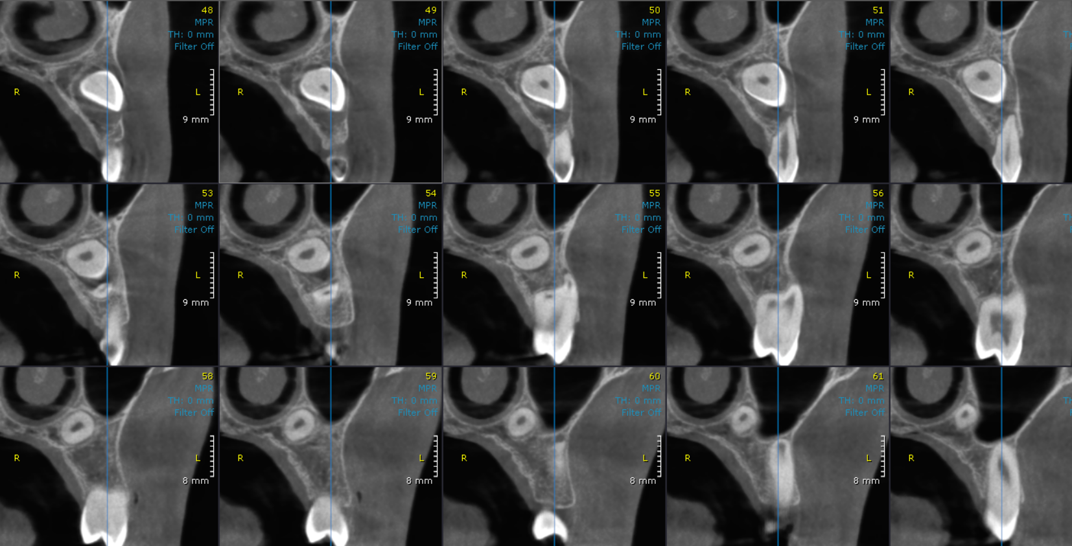
CROSS- SECTIONAL IMAGES

**** End of report ****

